Recruitment and Selection of Seafarers

https://youtu.be/kI4-qwsUoxM?si=m7LwEVTpuaCaiBAx

The Recruitment and Selection Process in a Manning Agency involves sourcing, screening, and deploying qualified seafarers to shipowners, ensuring compliance with statutory and regulatory bodies such as STCW, MLC, SOLAS, etc.
This is a structured approach organizations use to attract, evaluate, and hire the most suitable candidates for a job. While often used together, they are two distinct phases:
- Recruitment = attracting a pool of candidates
- Selection = choosing the best candidate from that pool

Job Analysis
This is the foundation of the entire process.
- Identifies job responsibilities, skills, qualifications, and experience required
- Produces two key outputs:
  - Job Description (JD) – duties and responsibilities
  - Job Specification – qualifications, skills, traits
👉 Without proper job analysis, hiring can become inconsistent or ineffective.

This process is being mentioned in Avior Marine QMS Manual under QP8 of the Standard Procedure as well as on Work Instruction WI08.

Module 1. Vacancy Identification
Vacancy identification in the seafaring industry is a critical human resource function that ensures ships are always properly manned with qualified personnel. It combines planning, forecasting, and compliance to maintain operational efficiency and maritime safety.
This is the initial step where the need for a new applicant based on the request of the Fleet Team is recognized. It may arise due to several factors:
• End of Contract
Seafarers typically work on fixed-term contracts (e.g., 6–9 months). When contracts end, replacements are needed.

• Promotion
A crew member may be promoted (e.g., Third Officer → Second Officer), creating a new vacancy.

• Emergency Replacement
Unexpected situations such as illness, injury, or family emergencies require urgent crew replacement.

• Expansion of Fleet
Shipping companies acquiring new vessels need additional crew.

• Compliance Requirements
International regulations require a minimum number of qualified crew onboard.
The job role, responsibilities, and qualifications are defined at this stage.
The request to hire new applicant/s is being done thru e-mail with each Fleet Team mentioning the required rank/s and other information which is essential to the Recruitment Department. The procedure for this initiative is being discussed in OPS-WI.08 item 5.1 (Receiving and Reviewing Crew Requirements) with details in sub item a to e as presented in Appendix-A

Appendix -A
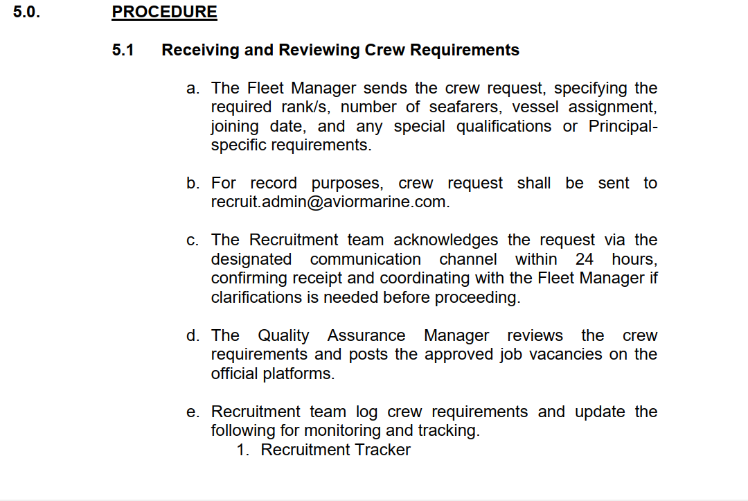

Module 2. Sourcing
In this stage, potential candidates are identified and attracted. This stage focuses on building a strong pool of applicants.
- Types of Recruitment:
- Internal Recruitment
  - Promotions
  - Transfers
  - Employee referrals
✅ Pros: Faster, boosts morale
❌ Cons: Limited talent pool

- External Recruitment
https://www.shutterstock.com/video/clip-3989131517-we-hiring-join-us-now-apply-animated
  - Job portals (e.g., Seaman Jobsite, LinkedIn, etc.)
  - Company websites
  - Colleagues from other Recruitment agencies
  - Campus hiring
  - Social media (e.g. Facebook, Twitter, etc)

Key Activities:
- Writing job ads
- Posting vacancies
- Employer branding
- Sourcing candidates
The process for this is being amplified in OPS-WI08 item 5.2 (Applicants applying to existing vacancy and officers) under sub item 5.2.1 (as presented in Appendix B).

Appendix-B
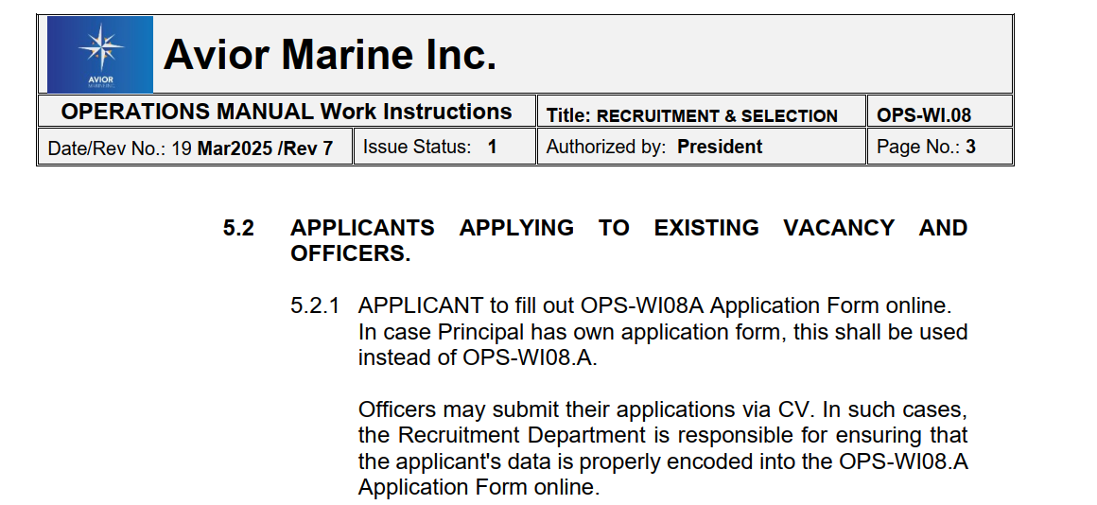

Recruitment Department is also accommodating Walk-In applicants for those who opted to visit Avior Marine Office directly. Others who preferred to send their personal CV’s online, Avior is also inclined to accommodate them. These processes are detailed in items 5.3 to 5.4 of the WI.08 (as excerpted in Appendix C).

Appendix-C
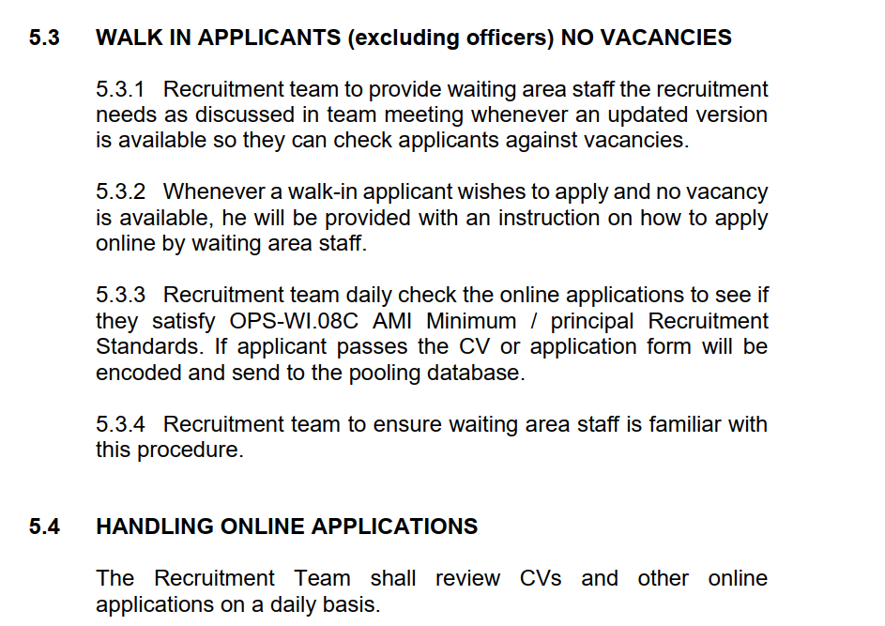
For Avior ex-crew which will be endorsed to another principal as part of internal hiring, the department facilitates the application as per Avior Marine procedure which is stated under item 5.5 sub items 5.5.1. to 5.5.3 of the WI.08. (as amplified by Appendix D)
Appendix-D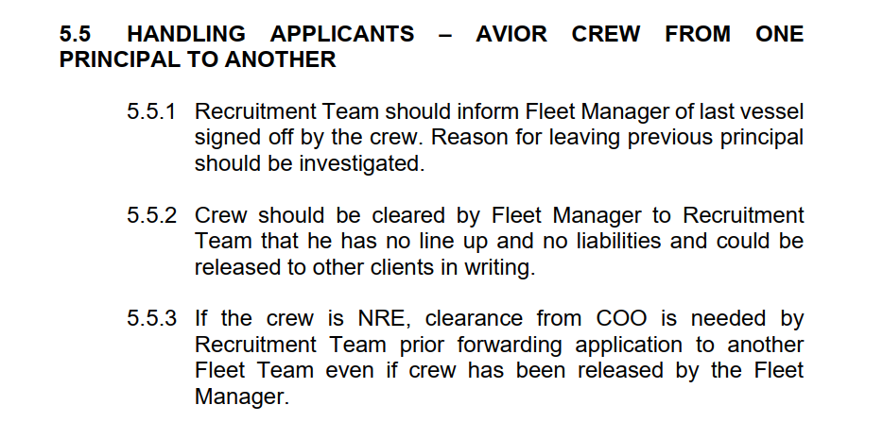

Module 3. Screening and Verification
Applications are reviewed to shortlist qualified candidates. Background checks, document verification, and initial evaluations are conducted to ensure candidates meet basic requirements.
Screening of Applications
This is the first filtering stage.
- Reviewing resumes/CVs
- Checking qualifications and experience
- Shortlisting candidates
👉 Some companies use Applicant Tracking Systems (ATS) to automate screening.

The details for the process can be found in OPS-WI08 item 5.2.2, 5.2.3, of the QMS Manual (as presented in Appendix-E).

Appendix-E
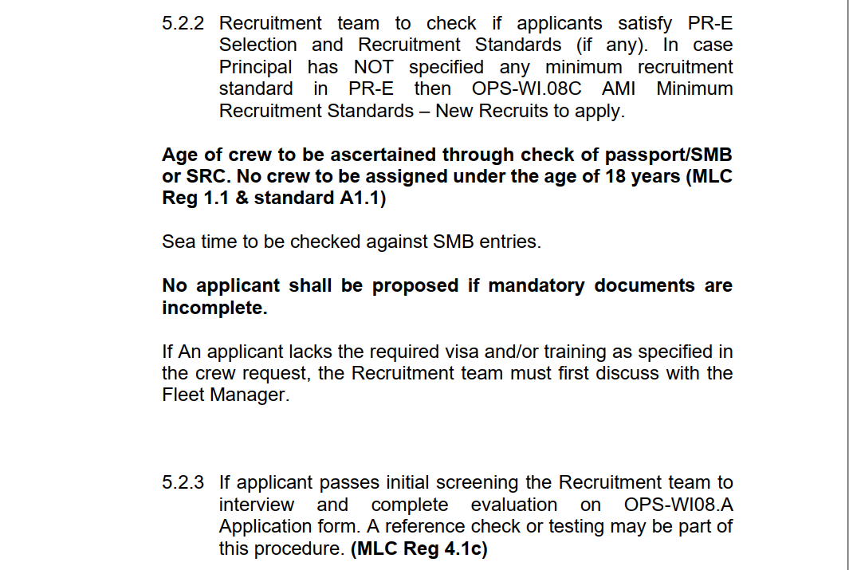
During the course of verification and screening, the interviewer will use the OPS-WI08.A (Avior Application Form-Digital Version) to document the initial interview process. Official Consent forms / Letters shall also be facilitated to further check the work background of the applicant. This undertaking is mentioned in WI-08 item A&B (Appendix-F)
Appendix-F
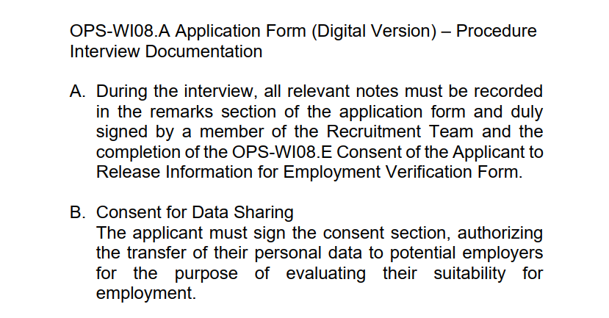
Module 4. Assessment, Selection and Testing
Shortlisted candidates undergo various assessments such as aptitude tests, technical exams, or personality tests to evaluate their skills, knowledge, and suitability for the role.
This stage involves deeper evaluation.

Common Selection Methods:
- Preliminary Interview
  - Basic questions
  - Communication check
- Assessment Tests
  - Aptitude tests
  - Technical tests
  - Personality assessments
- Main Interview
  - Structured or unstructured
  - Behavioral questions (e.g., “Tell me about a time…”)
- Background & Reference Checks
  - Past employment verification
  - Character references
- Decision Making
- Compare candidates based on:
  - Skills
  - Experience
  - Cultural fit
- Hiring manager selects the best candidate
👉 Sometimes multiple interviewers collaborate to avoid bias.
Recruitment staff may subject the applicant to undergo further Test such as CES Test and/or Marlins English Test to further appraise their knowledge and understanding of the English language.
The test/s will be facilitated by the Training Department thru e-mail request by the Recruitment Department. Result of which shall be made available by the training department and can be seen thru their e-mail.
Module 5. Endorsement to Fleet
Selected candidates are endorsed to the respective Fleet (or relevant department) for further evaluation of their suitability, competencies, experience and cultural fit. This may also include Principal or Technical Interview. This step ensures alignment with operational requirements before hiring is finalized. The details of which is being discussed in OPS WI.08 5.2, item C (details in attached Appendix G).

Appendix-G

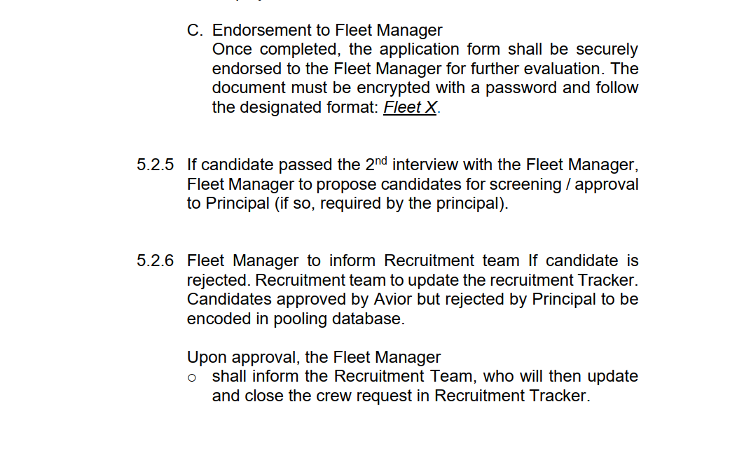

Module 6. Closing of Crew Requirements
Refers to the point when a job order for crew positions is officially completed, filled, or withdrawn.
- All required crew positions for a vessel are successfully filled, or
- The client (shipowner/principal) cancels or suspends the request, or
- The agency stops accepting applicants because enough candidates have been shortlisted
The steps being undertaken following this module is being amplified in WI.08 item 5.7 (as exhibited by Appendix H)

Appendix-H
